|  |  |  |  |
| --- | --- | --- | --- |
| System Name | Insert System Name Here | Block: BSIT 2 -C | Date Completed |
| Leader: | Jethro Owen P. Acuña |  | 12/03/2024 |
| Member: | Jella Marie Caceres |  |  |
| Member: | Gian Addy T. Maraño |  |  |
| Member: | Prince Louis M. Jaylo |  |  |

I. Project History

Write the timeline of your project from start to finish. Include screenshots of the commit history that shows major accomplishments of your team (e.g. finishing a certain page). Show the contribution of each member to the project.

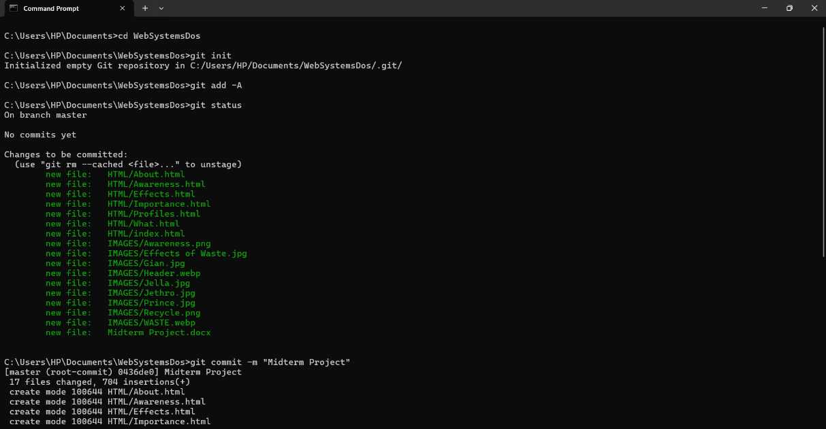

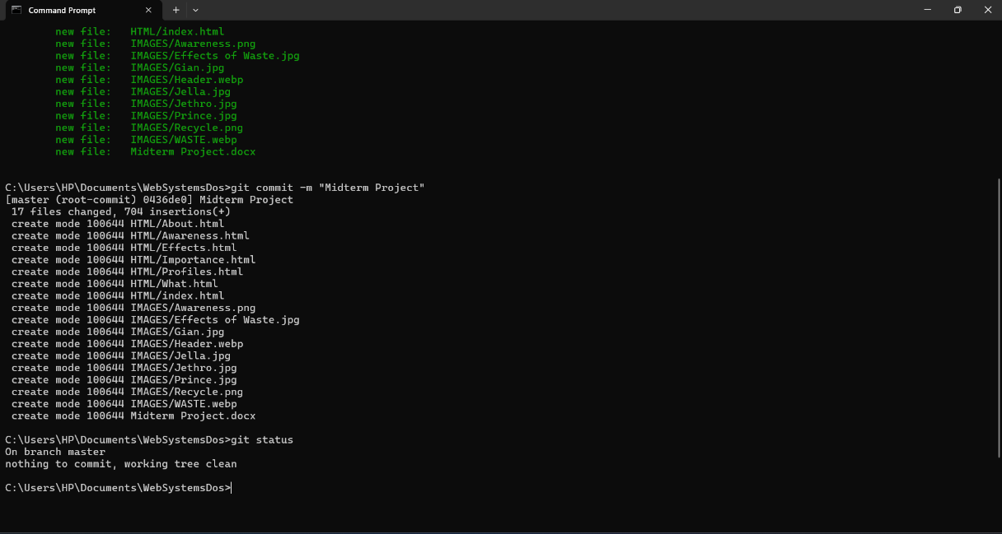

II. Site Performance Metrics

Show the performance metrics of each page in the site. Elaborate your findings. Include network and performance stats. Highlight the fastest and slowest pages and compare their results. Provide data that backs up your findings.

|  |  |  |
| --- | --- | --- |
| Webpage | Speed | Network Performance |
| index.html | 11ms | 297 B |
| What.html | 24ms | 8.8kb |
| Importance.html | 6ms | 297 B |
| Effects.html | 24ms | 7.9 kb |
| Awareness.html | 20ms | 6.1 kb |
| About.html | 22ms | 6.9 kb |
| Profiles.html | 24ms | 5.8 kb |

Green: Fastest  
Red: Slowest

III. SEO Cite the search engine optimizations that you have included in the creation of the site. Explain how they are utilized.

1. Quality Content Creation*: Create high-quality, valuable content that addresses the needs and interests of your target audience. Content should be original, well-written, and engaging. Regularly update your content to keep it fresh and relevant.
2. Optimized Page Titles and Meta Descriptions*: Craft descriptive and compelling titles and meta descriptions for each page of your website. These elements appear in search engine results and can significantly impact click-through rates.
3. Optimized Images and Alt Tags*: Use descriptive file names and alt tags for your images to improve accessibility and provide additional context to search engines. Optimized images can also appear in image search results, driving additional traffic to your website.
4. Social Media Integration*: Integrate social media sharing buttons and encourage sharing of your content on social platforms. While social signals may not directly impact search rankings, increased visibility and engagement on social media can indirectly benefit your SEO efforts.